**Program 8: Water Jug Problem**

**Aim**

To write a Python program to solve the **Water Jug problem** using the Breadth-First Search (BFS) approach.

**Algorithm**

1. Define two jugs with capacities jug1 and jug2.
2. Define the target amount of water to be measured.
3. Start from the initial state (0, 0) (both jugs empty).
4. Use BFS to explore all possible states by performing actions:
   * Fill Jug 1.
   * Fill Jug 2.
   * Empty Jug 1.
   * Empty Jug 2.
   * Pour water from Jug 1 → Jug 2.
   * Pour water from Jug 2 → Jug 1.
5. If a state matches the target amount, stop and display the solution path.
6. Avoid revisiting already visited states.

CODE :

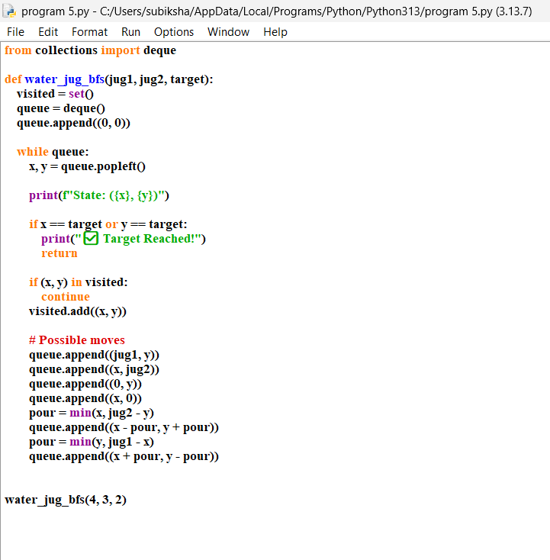

OUTPUT:

